RENFREWSHIRE BOWLING ASSOCIATION
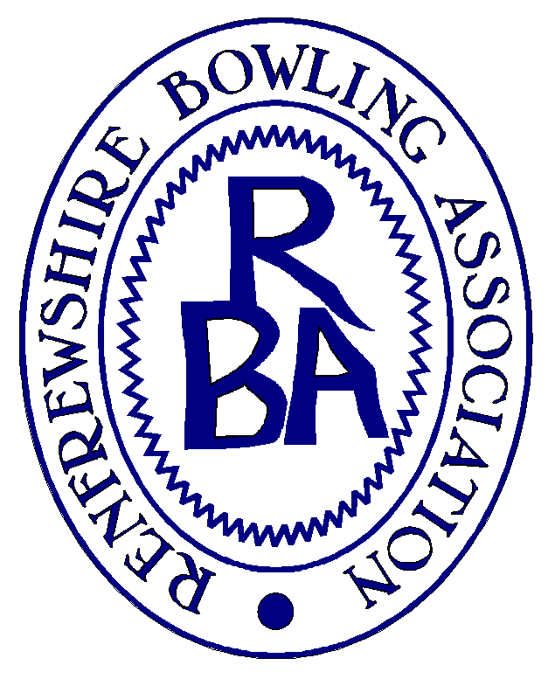
Sponsored by COLMED Ltd, Medical services
Calcluth & Sangster (Insurance Brokers)
0141 882 4512
GENERAL INFORMATION
The draws for all disciplines are attached and have been made in four sections, except the Top 10, Sponsored Fours and Under 45’s competition that are an “all-in draw”.
The draw for the County Cup and Centenary Cup will be issued in due course and any questions on these should be being referred direct to Association Secretary Hugh Balfour
In the event of bad weather interfering with play, games shall take place on the same greens the following playable evening, and in any event before the date of the following Round.
Secretaries should arrange to reserve rinks for games due to be played on their greens and also appoint an umpire. The Association will appoint umpires for the Semi-Finals and Finals.
Substitution:- allowable up to, but not including, the ¼ final round as per Bowls Scotland rules stage 1, Stage 2 applies for the quarter-finals, semi-finals and finals.
All bowls must be stamped in accordance with Bowls Scotland current rules, including the requirement to have serial numbers on all bowls.
Dress code: - all rounds will be as per current Bowls Scotland rules regarding stage 1.
A full copy of the Competition and Championship Rules are posted on the RBA website
All finals will be played at Rankin Park Bowling Club on Sunday 24 June 2018 starting at 10.00am, All players should arrive no later than 30 minutes prior to finals commencing.
The winners will receive possession of the appropriate competition trophy for a year.
Host clubs must post completed scorecards to Stephen McLellan, 49 Riverside Road, Greenock, PA15 3AQ immediately after the conclusion of the game. NB Full names should be entered on scorecards.
It would assist if immediately following matches results could be forwarded by phone call or text to 07949 189572; or emailed to stephenmclellan@hotmail.co.uk
In the event of a question or query on the championship draws, please refer initially to Stephen McLellan

